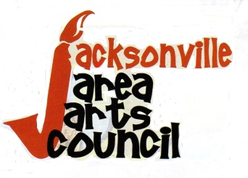 2015 Cooking/Recipe Contest

Saturday, October 24, 2015 at the Norman Activity Center,
Commerce Street, Jacksonville

Jacksonville Area Arts Council is happy to announce the addition of an Autumn Themed Cooking contest to the 4th Annual Autumn Art Show & Sale. This contest is open to non-professionals who want to compete for First Place bragging rights and show off their favorite autumn inspired recipe and skill in preparing it.

We’re looking for Entrée and Dessert categories, but if you’re feeling ambitious, you can enter both! Prepare and present your dish by 12:30 pm along with the attached Entry and Recipe forms. Judging will be held promptly at 1pm at the Norman Activity Center.

We are proud to announce our Culinary Judges: professional baker, Rachelle Coughlin and restaurateurs, Luke Wilson, manager of Chili’s and Imran Jiwani, owner of Denny’s, in Jacksonville.

Contestants are competing for $100 cash for the First Place Winners. Competition Ribbons will also be awarded for Second and Third Place recipes.

www.jacksonvilleareaartscouncil.com

903-586-2776 or 903-586-6140
P.O. Box 8406, Jacksonville, TX 75766

^{Annual Autumn Art Show & Sale}
^{2015 Cooking/Recipe Contest}
^{Entry& Recipe Form}
Contestant’s Name___________________________________________________
Address______________________________________________________________
Email Address____________________________Phone______________________

RECIPE: Entrée_______________________Dessert_________________________

Ingredients:______________________________________________________________________________________________________________________________________________________________________________________________________________________________________________________________________________________________________________________________________________________________________________________________________________________________
Instructions:___________________________________________________________________________________________________________________________________________________________________________________________________________________________________________________________________________________________________________________________________________________________________________________________________________________________________________________________________________________________________________________ _____________________________________________________________________________________________________________________________________________________________________________________________________________________________________________________________________________________________________________________(use back of this form if needed).

Judges Vote:_____________________ _________________________ ________________________

